**2025 INTERNSHIP REPORT**

**Submitted to : Smart Internz ,Smart Bridge company**

**Track : Data Analytics with Tableau**

**Submitted by:**

**Team ID : LTVIP2025TMID21129**

**Team Leader : Manda Bala Karthik**

**Team member : Loya Avinash Babu**

**Team member : Kunam Gopi Reddy**

**Team member : M Gowri Nandan**

**From:SeshadriRao Gudlavalleru Engineering College,**

**Gudlavalleru**

1. **INTRODUCTION**

**1.1 Project Overview**

**Project Title:**

***“iRevolution: A Data-driven Exploration of Apple's iPhone Impact in India using Tableau Visualization”***

**Project Summary:**

This project focuses on **A Data-driven Exploration of Apple's iPhone Impact in India using Tableau** is a visualization-based analytical project that examines the influence of the iPhone on the Indian market. By leveraging Tableau's advanced data visualization tools, the project explores key areas such as market penetration, sales trends, user demographics, and cultural impact. Using data from sales records, social media sentiment, and market research, it offers actionable insights for stakeholders—including Apple, local competitors, and analysts—highlighting how iPhone adoption is shaping consumer behavior and market dynamics in India.

**Objectives:**

• Analyze iPhone sales trends across regions and time periods in India.

• Identify key user demographics and adoption patterns.

• Assess cultural and social media impact of iPhone usage.

• Create interactive Tableau dashboards for data visualization.

• Offer strategic insights for market growth and customer targeting.

**Scope:**

**In-Scope:**

* Data cleaning and preparation of iPhone sales, demographic, and social media data.
* Exploratory data analysis using Tableau.
* Creation of dashboards showcasing sales trends, user demographics, and cultural impact.
* Generating insights and reports for stakeholders on iPhone market influence in India.

**Out-of-Scope:**

* Real-time data tracking or live integration with sales systems.
* Development of mobile or hardware-based data collection tools.

**Timeline:**

* **Week 1–2:** Data collection and preprocessing
* **Week 3–4:** Exploratory data analysis and initial dashboard development
* **Week 5:** Insights generation and final dashboard enhancements
* **Week 6:** Report preparation and presentation **Key Stakeholders:**
* **Project Sponsor:** Smart Bridge Company
* **Project Manager:** Indra Prakash sir
* **Data Analyst / Visualization Developer:**
* Team Leader : Manda Bala Karthik
* Team member : Loya Avinash Babu
* Team member : Kunam Gopi Reddy
* Team member : M Gowri Nandan

**End Users:**

* Marketing and Sales Teams
* Market Analysts
* Business Strategists at Apple and competing brands

**Tools & Technologies:**

* Tableau for data visualization
* Excel/SQL/Python for data preprocessing
* **Datasets:** iPhone sales records, user demographic data, market research reports, and social media sentiment data

**Risks and Dependencies:**

* **Risk:** Limited or inconsistent access to reliable demographic and social media sentiment data
* **Mitigation:** Use verified third-party market research and social media analytics tools to supplement gaps
* **Dependency:** Timely access to historical sales and product layout data

**1.2 purpose:**

The purpose of "iRevolution: A Data-driven Exploration of Apple's iPhone Impact in India" is to analyze and visualize the influence of Apple's iPhone on the Indian smartphone market. This project utilizes data analysis techniques and Tableau visualizations to explore key aspects, including¹ ²:

* Relationship between brand names and product names: Understanding how Apple's brand and iPhone products interact with consumer preferences.
* Sales prices and consumer behavior: Examining how pricing strategies impact iPhone sales and consumer purchasing decisions in India.
* Market trends and insights: Providing valuable information on the Indian smartphone market, focusing on Apple's market share, growth, and competition.

By employing data-driven approaches, the project aims to deliver actionable insights into the Indian smartphone market, shedding light on Apple's iPhone impact and its implications for the industry.

1. **IDEATION PHASE:**

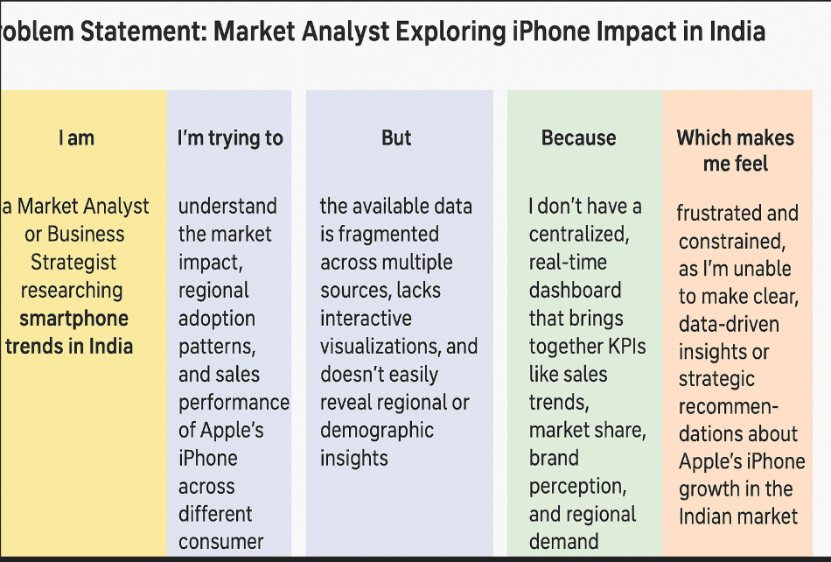

* Problem Statement 1: Market Penetration and Sales Trends
* Problem Statement 2: User Demographics and Preference
* Problem Statement 3: Cultural and Social Media Impact

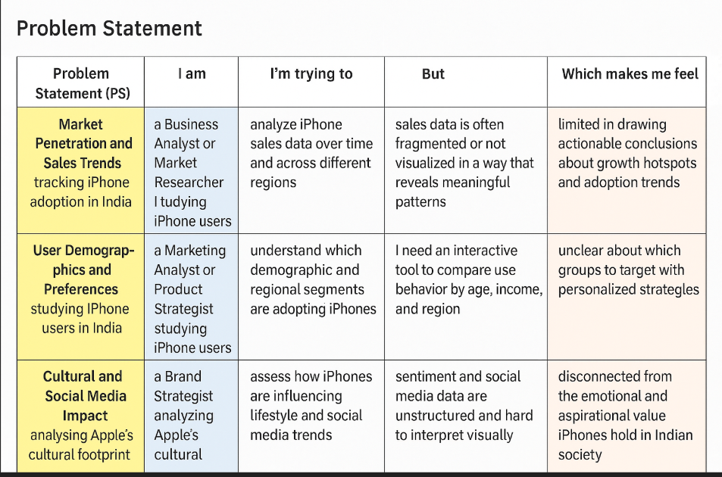

* 1. **Empathy Map Canvas:**

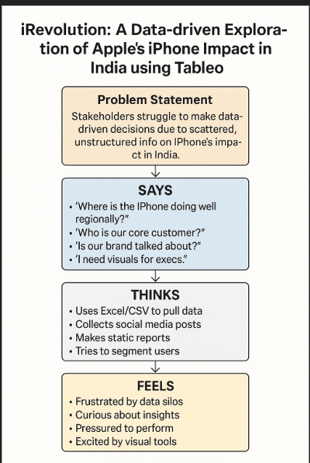

**2.2Brainstorming:** 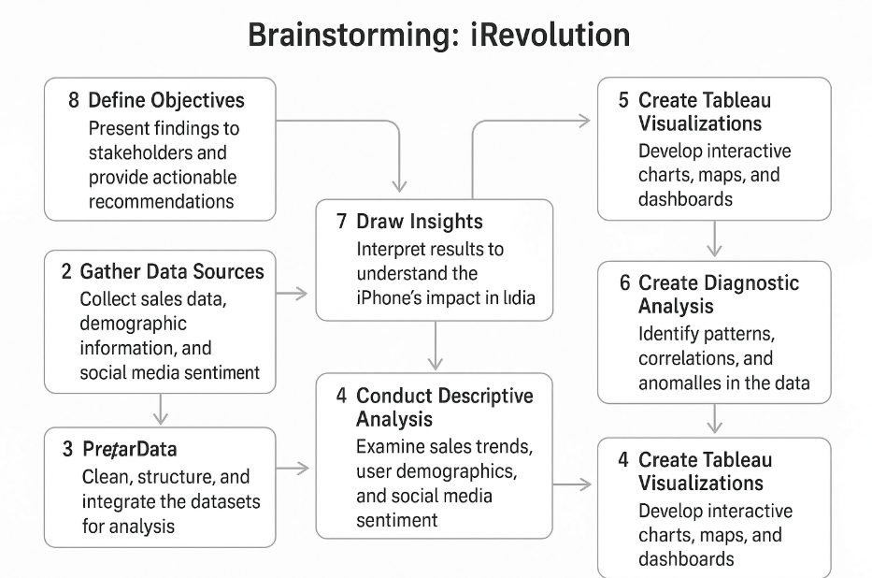

1. **REQUIREMENT ANALYSIS :** 
   1. **Customer Journey Map :**

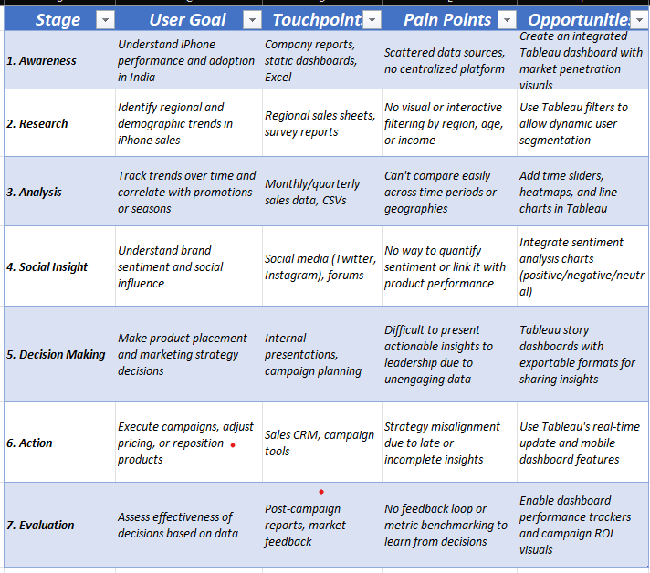

* 1. **Solution Requirement:**

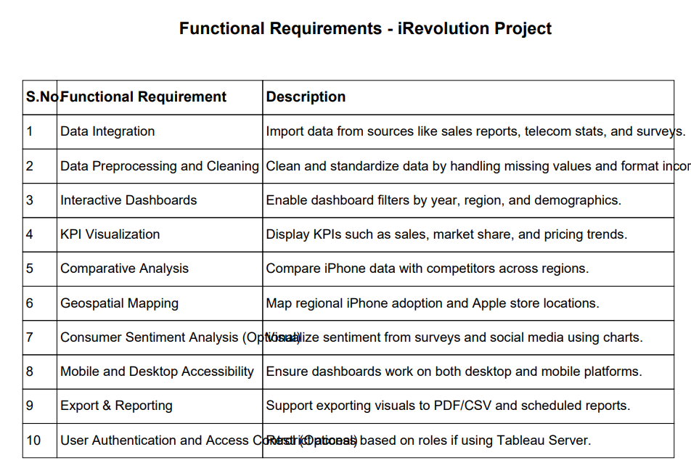

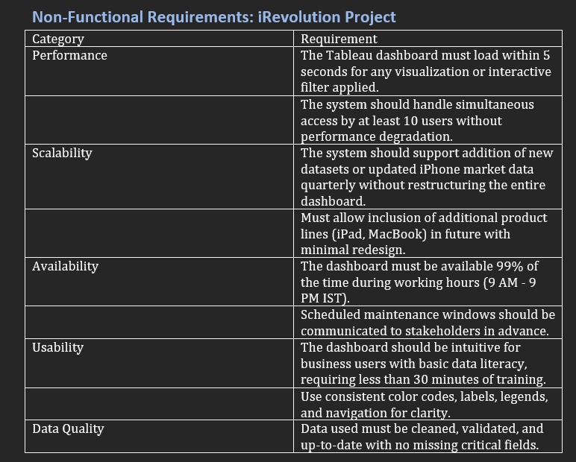

* 1. **Data Flow Diagram:**

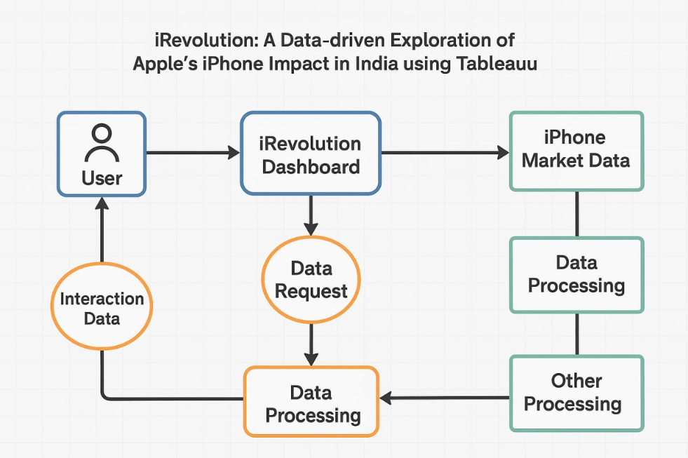

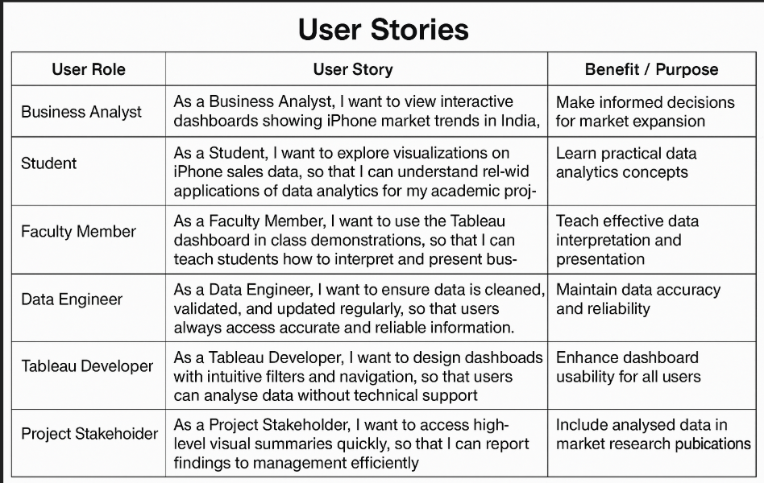

* 1. **Technology Stack:**

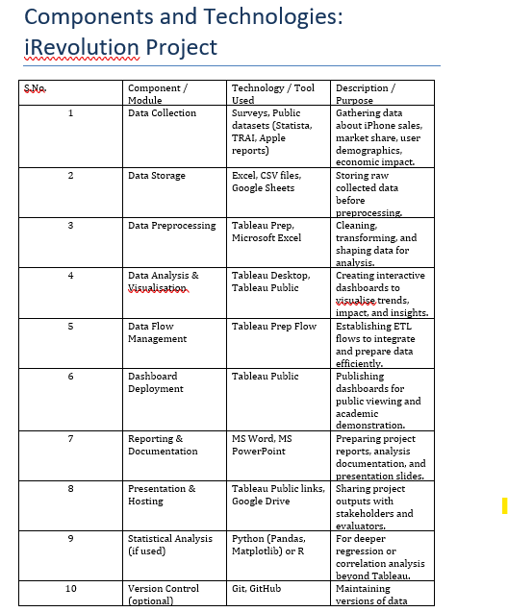

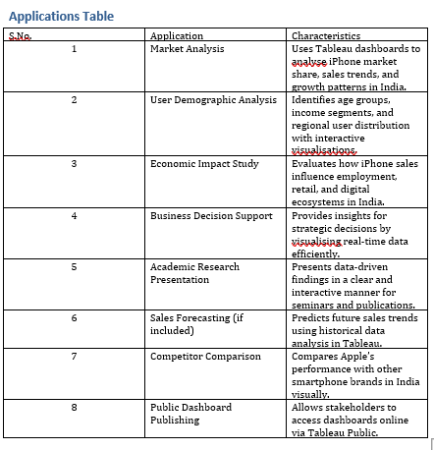

1. **PROJECT DESIGN:**

**4.1Problem solution Fit:**

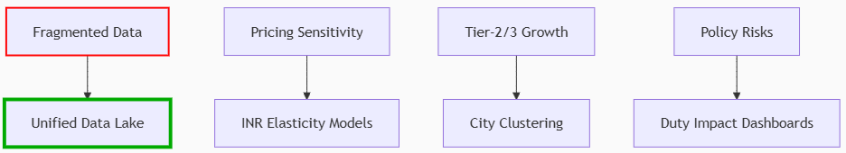 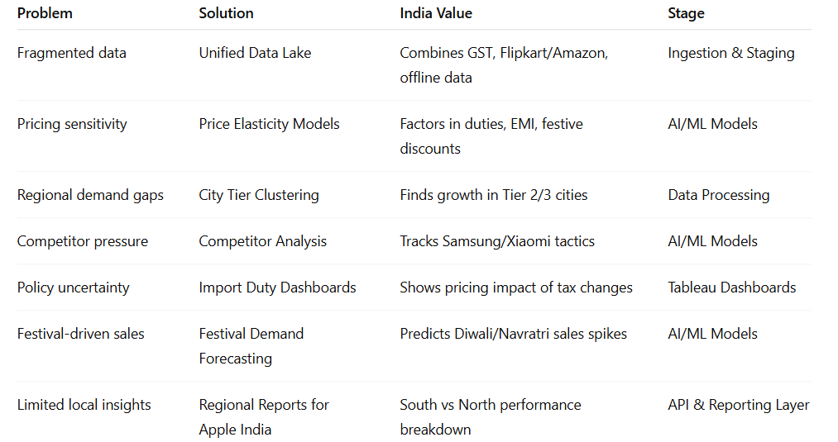

* 1. **Proposed Solution:** 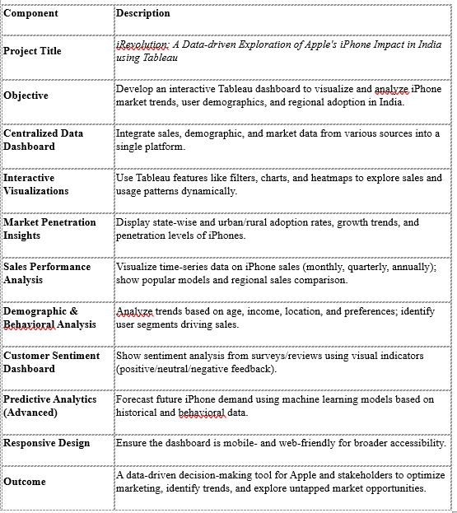

* 1. **Solution Architecture:** 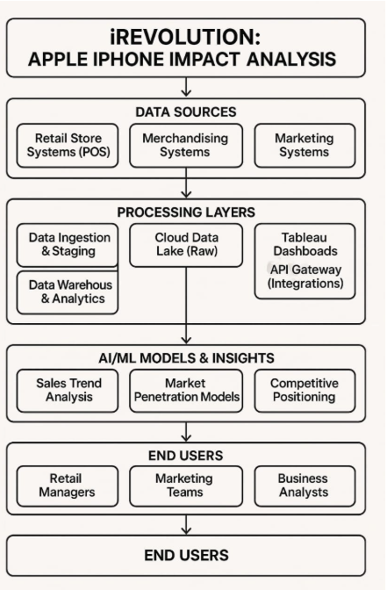

1. **PROJECT PLANNING & SCHEDULING:**

**5.1 Project planning:**

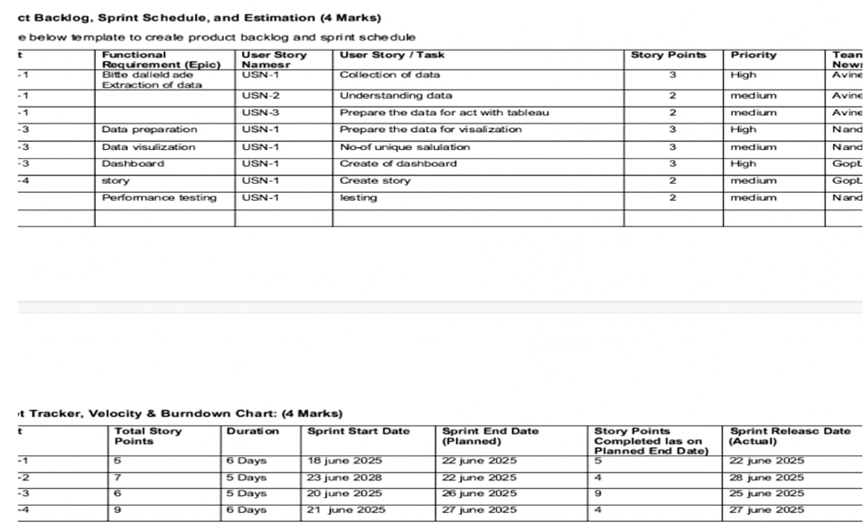

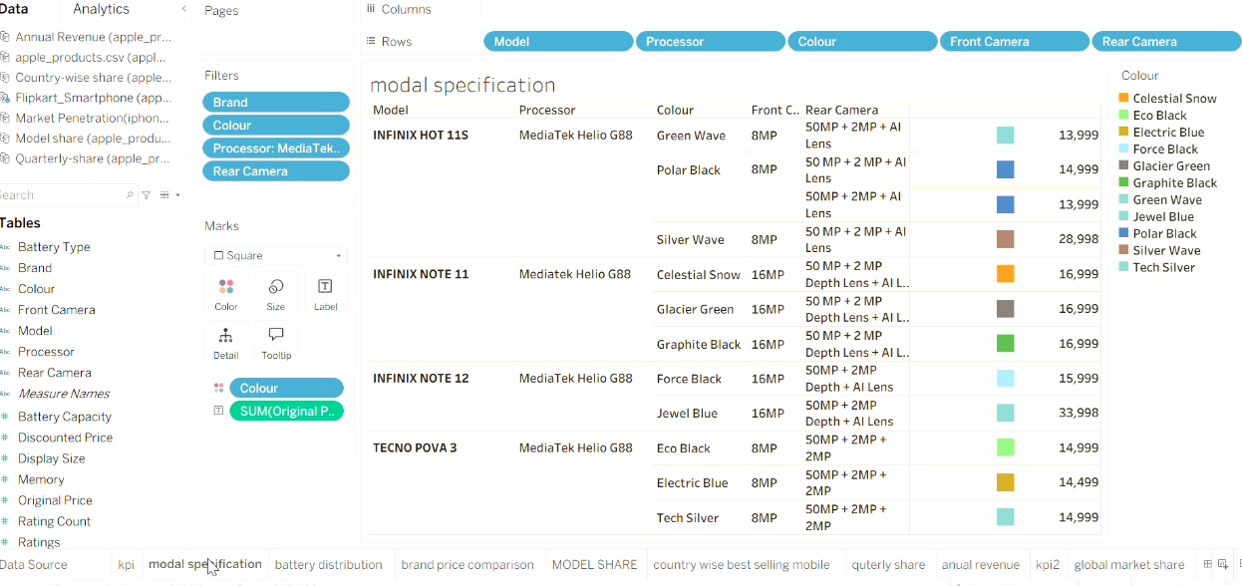

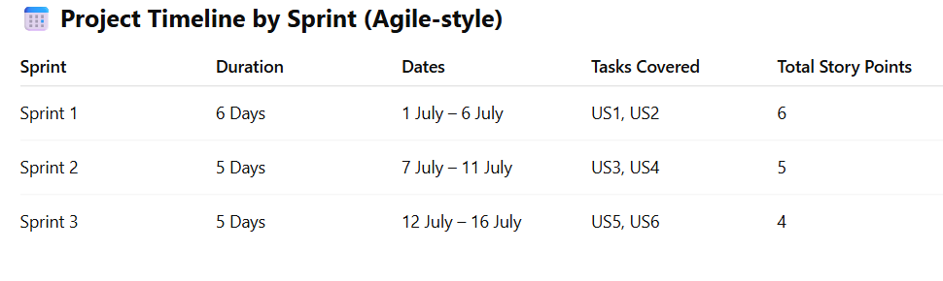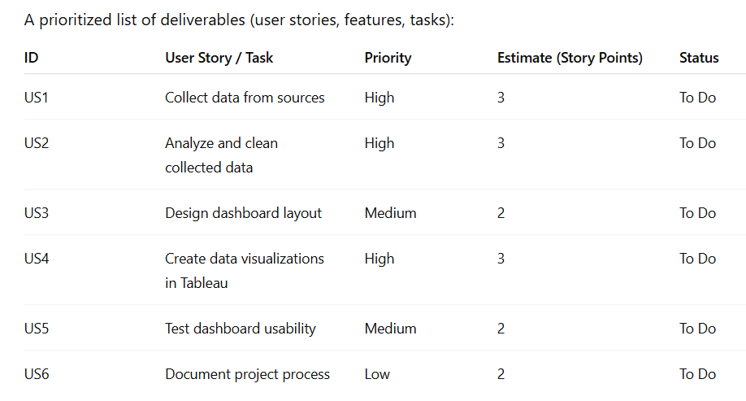

**FUNCTIONAL AND PERFORMANCE TESTING:**

**6.1 Performance Testing:** 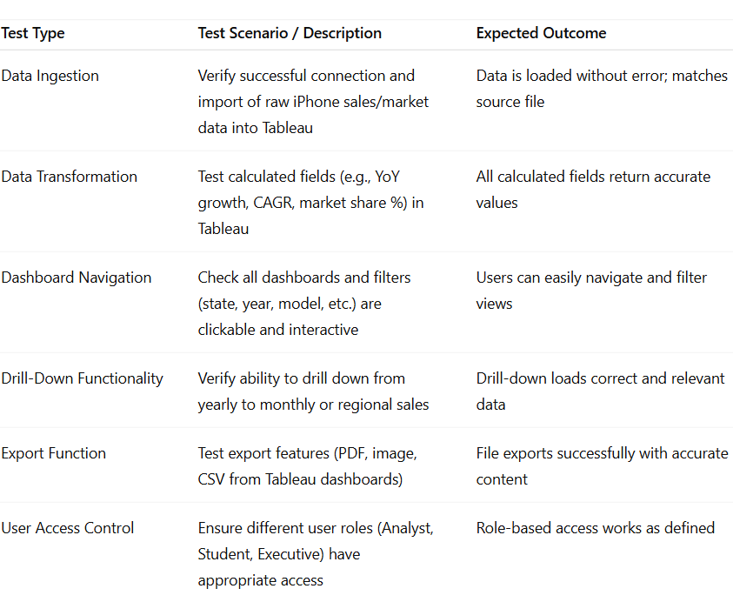

1. **RESULTS:**

**7.1 Output Screenshot:**

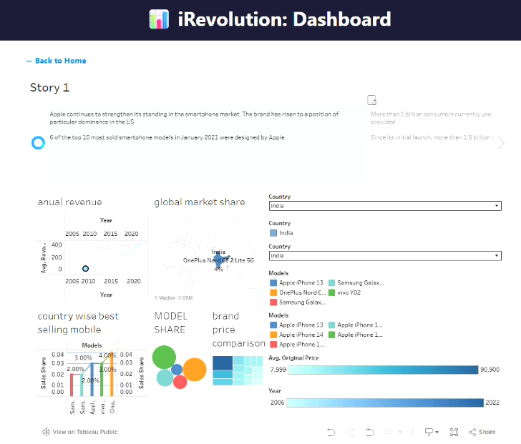

**Story:** 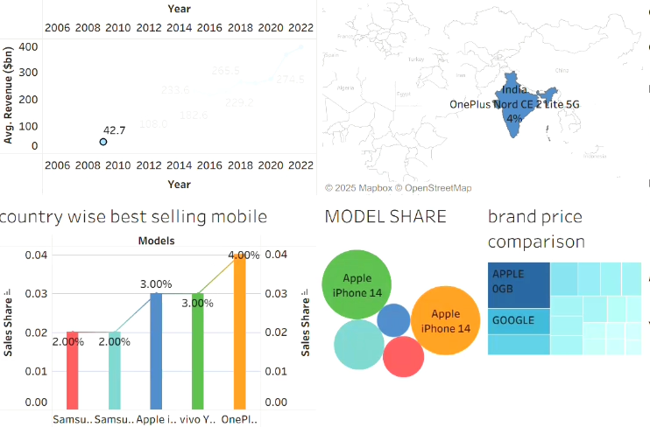 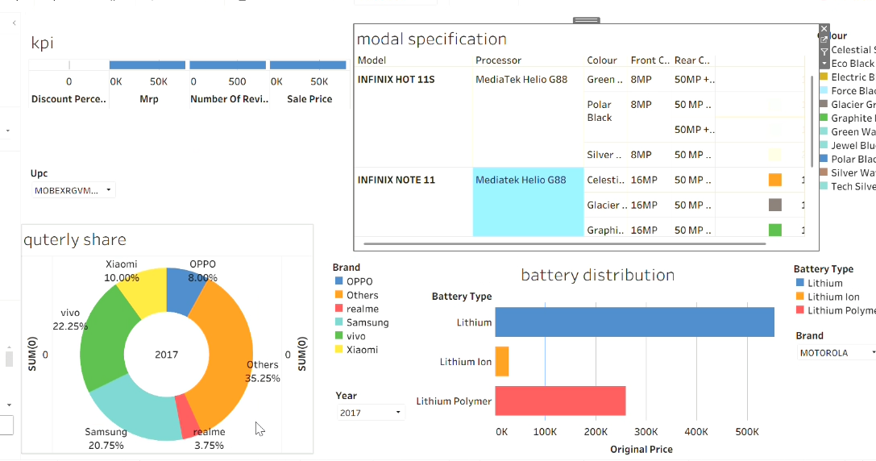 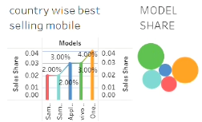 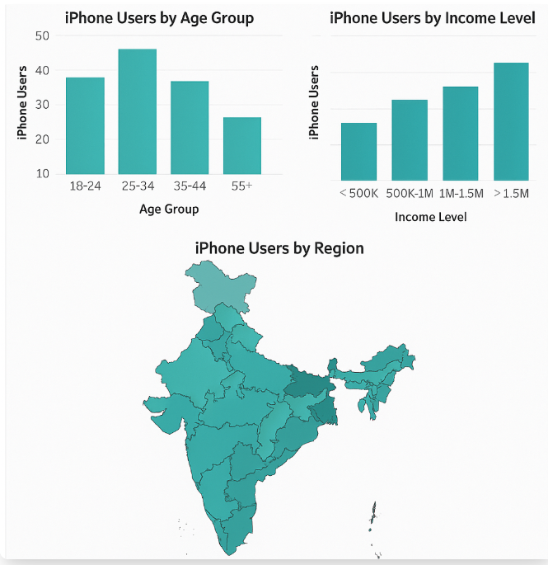

8.**ADVANTAGES & DISADVANTAGES :**

**Advantages:**

**Data-Driven Decision Making:**

* Helps understand regional iPhone penetration and market trends in India.

**Enhanced Sales Strategy Development**

* Identifies high-growth regions, effective sales channels, and marketing opportunities.

**Consumer Behavior Insights:**

* Tracks buying patterns, upgrade cycles, and brand loyalty among Indian consumers

**Effective Use of Tableau:**

* Presents insights through interactive dashboards and visuals understandable by all stakeholders

**Cost Optimization:**

* Highlights underperforming areas to optimize sales force and marketing budget allocation.

**Competitive Advantage:**

* Compares Apple’s performance with Android competitors across different Indian markets. Complex Initial Setup

**Disadvantages:**

**High Data Dependency**

* Requires clean, accurate, and updated data; poor data quality can lead to incorrect conclusions.

**Complex Initial Setup**

* Needs integration of various data sources and technical setup for Tableau dashboards.

**Rapidly Evolving Market Dynamics**

* Indian smartphone trends shift quickly, making static insights less reliable over time.

**Tool Limitations in Predictive Analysis**

* Tableau lacks advanced machine learning or forecasting tools compared to specialized platforms.

**Implementation Costs**

* High initial costs for software, skilled personnel, and data acquisition.

**Overemphasis on Visuals**

* Users may prioritize attractive visuals over deep, contextual business understanding.

**Dynamic Market Conditions:**

* Consumer preferences and market trends change frequently, making it hard to maintain consistently optimal placements.

**Tool Limitations:**

* Tableau is a powerful tool, but it may have limitations in advanced predictive modeling or real-time analytics compared to specialized tools.

**Cost of Implementation:**

* Investment in tools, training, and data infrastructure may be significant for small businesses.

**Over-reliance on Visualization:**

* Users might focus more on visuals than on underlying business logic, possibly ignoring key qualitative insights.

**9. CONCLUSION:**

The “*iRevolution* project” showed us how powerful data and visual analytics can be when it comes to understanding Apple’s iPhone impact in India. Using Tableau really helped us break down complex data and turn it into clear, visual insights about sales patterns, regional performance, customer preferences, and how Apple compares to other smartphone brands in the market.

What we learned is that relying on assumptions or surface-level analysis isn’t enough anymore—especially in a market as large and fast-changing as India. With tools like Tableau, we can look at trends in a way that’s easy to understand and share, making it easier to adjust strategies across different regions, customer groups, or product lines.

Of course, the project came with its challenges, like needing good-quality data and the effort involved in setting up everything. But overall, the benefits—like better decision-making, clearer targeting, and stronger competitive awareness—really stood out.

One of the key takeaways is that analyzing market impact like this isn’t a one-time job. It’s something that needs to be updated and reviewed regularly to keep up with changing trends and consumer behavior. This kind of analysis can truly help Apple and other businesses stay ahead in a competitive space.

**10.FUTURE SCOPE :**

**Integration with Real-Time Data:**

* We could bring in real-time sales and inventory data to help track iPhone performance dynamically and respond to trends as they happen.

**AI & Machine Learning Enhancements:**

* By integrating predictive models, we can forecast future iPhone sales in different regions and identify potential growth opportunities based on consumer patterns.

**Customer Heatmap & Footfall Analysis:**

* In physical retail settings, using sensor or camera data to create heatmaps would help us understand where footfall is highest, helping optimize product visibility and in-store positioning.

**Cross-Channel Analysis:**

* Expanding the project to include online platforms would let us compare digital and physical sales side-by-side, giving a complete picture of Apple's market impact in India.

**Personalized In-Store Experience:**

* Combining sales and loyalty data could help tailor marketing efforts and in-store product placement to different customer segments more effectively.

**Automated Tableau Dashboards:**

* Setting up auto-updating dashboards in Tableau would reduce manual work and allow stakeholders to get fresh insights instantly.

**Scalability Across Locations:**

* The current analysis can be extended to multiple regions or cities, allowing Apple to fine-tune strategies based on local consumer behavior and market conditions.

**AR-Based Layout Visualization:**

* Using Augmented Reality, we can simulate new store layouts or promotional placements before actually making changes—helping to test ideas faster and more efficiently.

**Sustainability in Inventory**:

* Using the insights from the analysis, Apple and its partners can avoid overstocking and improve shelf efficiency, contributing to greener, more sustainable operations.

**Campaign Integration**:

* By linking sales data with marketing campaigns, we could measure how promotional efforts impact customer engagement and iPhone sales more effectively.

**11.Acknowledgement / Thank You Note:**

I would like to express my heartfelt gratitude to **Indraprakash Sir**, my internship mentor, for his continuous guidance, support, and encouragement throughout this project. His expertise and insights have been invaluable in shaping my understanding of data analytics and visualization.

I also extend my sincere thanks to **SmartInternz** for providing this valuable opportunity to work on a real-world project and gain practical experience in tools like Tableau. This internship has been an enriching and rewarding learning journey.

Thank you once again for your constant support and mentorship.

11. **APPENDIX:**

**Tools & Technologies Used**

**Tableau Public / Desktop** – For data visualization and dashboard creation

**Microsoft Excel** – For data cleaning, preparation, and preprocessing

**Google Sheets** – For online collaboration and dataset sharing **SmartInternz Platform** – For internship guidance and submissions **Data set link:**

**https://drive.google.com/drive/folders/1VfD_oYTfbBgkpYDX8o8bIIzxHqWcVi7u?usp=sharing**

**Tableau Public Link:**

[https://www.google.com/search?q=tableau+public&oq=table&gs_lcrp=E gZjaHJvbWUqBggBEEUYOzIGCAAQRRg8MgYIARBFGDsyBggCEE UYOTIGCAMQRRg7MgYIBBBFGDwyBggFEEUYPDIGCAYQRRg8](https://www.google.com/search?q=tableau+public&oq=table&gs_lcrp=EgZjaHJvbWUqBggBEEUYOzIGCAAQRRg8MgYIARBFGDsyBggCEEUYOTIGCAMQRRg7MgYIBBBFGDwyBggFEEUYPDIGCAYQRRg8MgYIBxBFGD3SAQg0MzI5ajBqN6gCCLACAQ&sourceid=chrome&ie=UTF-8)

[MgYIBxBFGD3SAQg0MzI5ajBqN6gCCLACAQ&sourceid=chrome&ie =UTF-8](https://www.google.com/search?q=tableau+public&oq=table&gs_lcrp=EgZjaHJvbWUqBggBEEUYOzIGCAAQRRg8MgYIARBFGDsyBggCEEUYOTIGCAMQRRg7MgYIBBBFGDwyBggFEEUYPDIGCAYQRRg8MgYIBxBFGD3SAQg0MzI5ajBqN6gCCLACAQ&sourceid=chrome&ie=UTF-8)

**Github link:**

[**https://github.com/karthik-7498**](https://github.com/karthik-7498)

**Video Demo link:**

**https://drive.google.com/drive/folders/1VfD_oYTfbBgkpYDX8o8bIIzxHqWcVi7u?usp=sharing**